|  |  |  |  |  |
| --- | --- | --- | --- | --- |
|  | | | | |
| Multimedia Projector | | | | |
| **Vivitek DW832**  Wide Screen Multimedia Projector with MHL, Long Life Lamp and a Host of Connectivity Options | | | | |
|  | | | | |
| * WXGA (1280 x 800) resolution with 5,000 ANSI lumens of brightness and a 15,000 contrast ratio * 6 Segment (RYGCWB) color wheel for improved and vivid color reproduction * Quick auto search filtering to quickly locate input signal source * Variety of display connectivity options including: HDM (x2), VGA-in (2x), VGA-Out, S-Video and Composite Video * MHL device connectivity for streaming of content (video, audio, documents, presentations) from a compatible Andriod™ device * 3D compatibility with DLP® Link™ and HDMI 1.4b Blu-Ray support for dazzaling and realistic life-like images * Compatible with long VGA cables for a maximum length up to 20 meters * Enhanced envrionmentally friendly power functions (Eco mode, Auto power off, stand-by mode) to increase lamp life, power savings and engery consumption * Built-in 10W audio speaker with multiple audio-in and audio-out ports * Integrated Closed Caption Decoding (CCD) automatically converts the audio portion of a TV’s signal and displays it as subtitles on the projected screen * Hassle-free maintenance with top loading lamp door for convenient lamp replacement * Front/Rear infrared sensors for handy remote control from either in front or behind the projector * Anti-theft security features include: Kensington® security slot, security bar, and password protected keypad lock | | | | |
|  | | | | |
| **Photos** | | | | |
|  | | | |  |
| **Specifications** | | |  | |
| Display Type | Single 0.65" DLP Technology by TI | | | |
| Brightness | 5,000 ANSI Lumens | | | |
| Native Resolution | WXGA (1280x800) | | | |
| Maximum Resolution | WUXGA (1920x1200)@60Hz | | | |
| Contrast Ratio | 15,000:1 | | | |
| Lamp Life/Type | 2500/3000/3500 Hours (Normal/Eco./Image Care Mode), 310W/245W | | | |
| Throw Ratio | 1.46 - 2.20 | | | |
| Image Size (Diagonal) | 25.3” - 317.99" | | | |
| Projection Distance | 1.2 - 10m (3.94ft - 2.8ft) | | | |
| Projection Lens | F=2.42 - 2.97 , f=20.70 - 31.05mm | | | |
| Zoom Ratio | 1.5x | | | |
| Aspect Ratio | 16:10 Native | | | |
| Offset | 111.3±5% | | | |
| Keystone Correction | ±40 Degree; ±40 Steps | | | |
| Horizontal Frequency | 15, 31 – 91Hz | | | |
| Vertical Scan Rate | 24 - 30Hz, 47 - 120Hz | | | |
| 3D Compatibility | Yes (DLP® Link™, HDMI 1.4b (Blu-Ray)) | | | |
| Audio | 10W (Mono) | | | |
| Computer Compatibility | VGA, SVGA, XGA, SXGA, SXGA+, UXGA, WUXGA@60hz, Mac | | | |
| Video Compatibility | SDTV (480i, 576i) / EDTV (480p, 576p) / HDTV (720p, 1080i, 1080p), NTSC (M, 3.58/4.43 MHz), PAL (B,D,G,H,I,M,N) SECAM (B,D,G,K,K1,L) | | | |
| I/O Connection Ports | HDMI v1.4, MHL/HDMI v1.4, VGA-In (x2), S-Video, Composite Video, Audio-In (RCA L/R), Audio-In (Mini-Jack), VGA-Out, USB (Type A for 5V/1.5A Power Only), Audio-Out (Mini-Jack), RJ45, RS-232, Mini-USB (Service), Microphone (Mini-Jack), 12V Trigger | | | |
| Projection Method | Table Top, Ceiling Mount (Front or Rear) | | | |
| Security Solutions | Kensington® Security Slot, Security Bar, Keypad Lock | | | |
| Dimensions (WxDxH) | 319 x 216 x 126mm (12.5" x 8.5" x 4.9") | | | |
| Weight | 3.2kg (7lbs) | | | |
| Available Color | Two-Tone: White/Gray | | | |
| Noise Level | 38dB/34dB (Normal/Eco. Mode) | | | |
| Power Supply | AC 110-240V, 50/60Hz | | | |
| Power Consumption | 320W (Eco. Mode), 410W (Normal Mode), <0.5W (Standby Mode), <2W (LAN Standby Mode) | | | |
| Standard Accessories | AC Power Cord, VGA Cable, Remote Control, Filter (China only), Documentation Kit | | | |
| Optional Accessories | Replacement Lamp | | | |
| ©2015 Vivitek. Vivitek is a trademark of Delta Electronics, Inc. Other trademarks are the properties of their respective owners. Values, weights and dimensions shown are approximate. Errors and omissions accepted. Specifications are subjection to change without prior notice. | | | | |
|  | | |  | |



|  |  |  |  |  |
| --- | --- | --- | --- | --- |
|  |  |  |  |  |

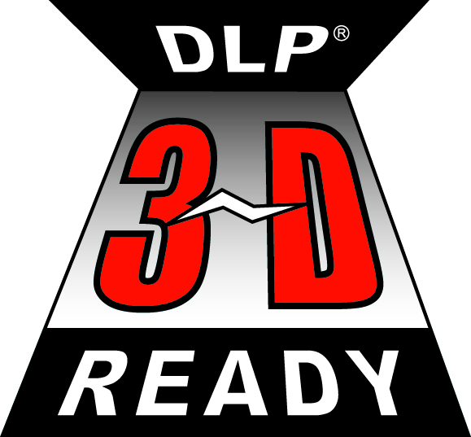roomview.jpg